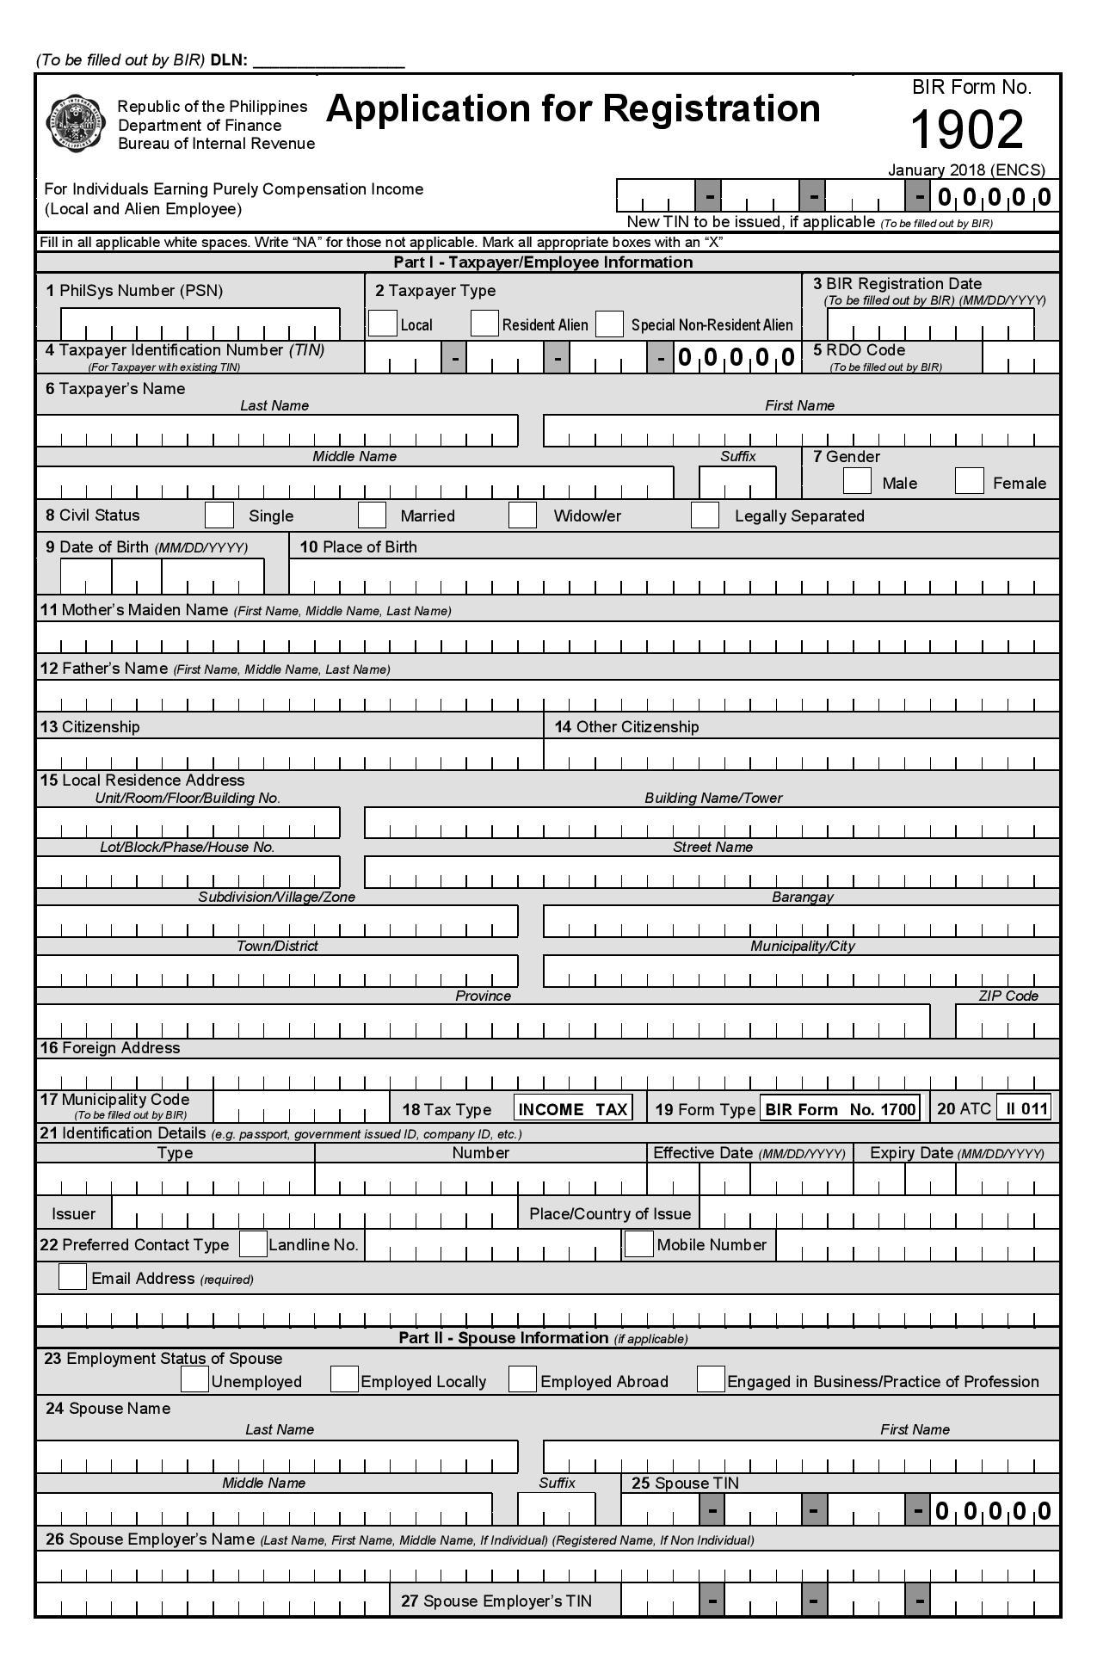

 |  |  |  |  |  |  |  |  |  |  |  |  |  |  |  | 0 | 0 | 0 |  | 8 | 6 | 3 |  | 9 | 5 | 8 |  | 6 | 2 | 3 |  |  |  |  |  |  | 0 | 3 | 6
D | E | P | A | R | T | M | E | N | T |  | O | F |  | E | D | U | C | A | T | I | O | N | - | D | I | V | I | S | I | O | N |  | O | F
P | U | E | R | T | O |  | P | R | I | N | C | E | S | A |  | C | I | T | Y
 |  |  |  |  |  |  |  |  |  |  |  |  | R | A | F | O | L | S |  | R | O | A | D
G | O | V | E | R | N | M | E | N | T |  | C | E | N | T | E | R |  |  |  | S | T | A | . |  | M | O | N | I | C | A
 |  |  |  |  |  |  |  |  |  |  |  |  |  |  |  |  |  |  |  | P | U | E | R | T | O |  | P | R | I | N | C | E | S | A
P | A | L | A | W | A | N |  |  |  |  |  |  |  |  |  |  |  |  |  |  |  |  |  |  |  |  |  |  |  |  |  |  |  |  |  | 5 | 3 | 0 | 0
 | 7 | 1 | 6 | - | 1 | 7 | 8 | 9
 |  |  | ATTY. ANNIZA M. BABAO |  |  |  |  |  |  |  |  |  |  |  |  |  |  |  |  | Attorney III  OIC Administrative Services
